PROJECT TITLE: Hummingbird Classification

PROJECT SUMMARY (Brief description of the goal, key analysis plan, key data feature- especially if the data is complex)

The purpose of this project is to build a hummingbird species classification model. During this project I will collect hummingbird images, create image pre-processing code for the data set, create a binary (male/female) bird classifier, create a species classifier, and use the classifier to predict future bird images.

MILESTONES (Bullet point STEPs in your project. You can tag “DONE” for things are done)

Project Timeline:

|  |  |  |  |  |  |  |  |  |  |  |
| --- | --- | --- | --- | --- | --- | --- | --- | --- | --- | --- |
| Task Week | | | 1 | 2 | 3 | 4 | 5 | 6 | 7 | 8 |
| Initial Project Proposal | | |  |  |  |  |  |  |  |  |
| Collect/classify photos from the web and my camera | | |  |  |  |  |  |  |  |  |
| Build data cleaning / hummingbird image processing tool | | |  |  |  |  |  |  |  |  |
| Create binary male/female classification model | | |  |  |  |  |  |  |  |  |
| Create multi-categorical species classification model | | |  |  |  |  |  |  |  |  |
| Draft Final paper / GitHub repository / Kaggle uploads | | |  |  |  |  |  |  |  |  |
|  | | | | | | | | | | |
|  |  | Done/In-progress |  | Overdue | | |  | Planned | | |

PROPOSED ‘TO DO’ FROM THE LAST WEEK (Copy & Paste from your previous week’s TO DO)

1. Data collection/hummingbird images – continues.
2. Data cleaning/classification has started ahead of plan.

THIS WEEK’S PROGRESS (Give bullet points and briefly explain what you accomplished or dealt with some of the milestones during the week)

1. Collection of hummingbird images has started. Images are coming into my camera, but I do need a better way to segregate the usable images from the empty/no bird images.
2. I started to upload code to my github repository: <https://github.com/amandakkimball/Hummingbird-Data-Collection-Classification>
3. I created an image preprocessing code in python to convert my images (camera or from the internet) to the same size/shape for modeling purposes.
4. I created a code to pull small images off my camera’s video feed. This is discussed in detail below.

ISSUES AND DISCUSSION (Bring up any difficulties and things to discuss. Also, send me a reminder if you want to discuss sooner)

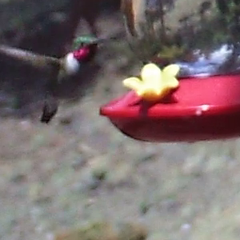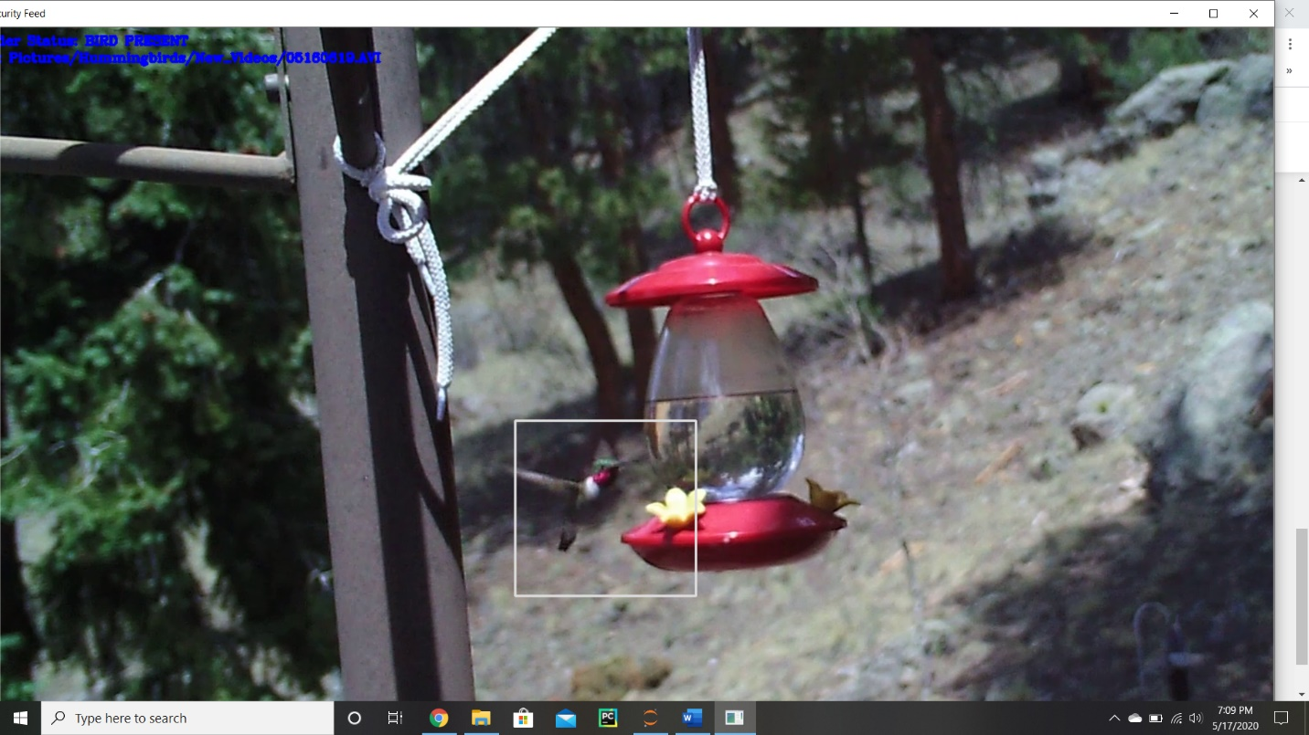During this week I began to collect photos of birds from online and also 10 second video clips using my game cam. I also wrote a program using opencv to strip the bird images from the video. An image from the video scan is displayed below:

During this video. The ruby throat humming bird is in the video for about 4 of the 10 seconds. The camera is using a background correction differential between the first image of the video and each image in the video to find anomalies/contours. I originally learned how to do this by following this tutorial [1]. It estimates the size of the contour and I resize that to 300x300 for consistent image sizes, which usually gets the full hummingbird. However, this 10 second clip captured 250 images and only 80 had hummingbirds in the shot and only about ½ of those were legible/unblurred birds. 40 images of this species is not a bad start. It is a form of natural augmentation since this one bird is seen its many different natural positions. I will create an initial binary identifier that will look for a humming bird within the image before it is saved to decrease my classification and cleaning workload.

TO DO (Give bullet points and briefly explain your plans for the next week)

1. Create a bird/no bird binary classification model to help sort the images collected.
2. Create bird directory so images can be moved into the correct slot as they are received.

RESOURCE (Optional: list resource or links you want to share with me)

[1] <https://www.pyimagesearch.com/2015/05/25/basic-motion-detection-and-tracking-with-python-and-opencv/>